TITLE OF THE PAPER

Smith, A.B.¹, Jones, C.D.² and Brown, E.F.³
¹ Department 1, Institution 1, Street, (P.O.Box if any), City, Post code, Country, email
² Department 2, Institution 2, Street, (P.O.Box if any), City, Post code, Country, email
³ Department 3, Institution 3, Street, (P.O.Box if any), City, Post code, Country, email

NOTE: DURING THE FIRST SUBMISSION THE NAMES AND INSTITUTIONS HAVE TO BE DELETED (For review process). THEY CAN BE ADDED IN THE SECOND SUBMISSION, AFTER THE ACCEPTANCE PROCESS (during the next June)

Abstract (PLEASE USE STYLE HEADING 1 centered)
Please apply style “Body Text” to this paragraph. The manuscript’s abstract should be in one paragraph and up to 300 words. Manuscript should not be larger than 12 pages including supporting illustrations. The manuscript should be compiled in the following order (AS IT IS SHOWN IN THESE INSTRUCTIONS): Title - in capitals, Author(s) - the name(s) (surname then initials), Affiliation/Organization of Author(s) and Mailing Addresses of the Author(s), Abstract, Nomenclature (complete listing), Introduction, Main Body, Conclusions, Acknowledgments, References, Appendices. The manuscript template is designed for A4 size paper (210 x 297 mm) with 2.5 cm (1 inch) margins at the top, bottom, left and right of your text. Text will be in Times New Roman 11 points font, single spaced.
1.0 EXAMPLE OF HEADING 1
1.1 Example of Heading 2
Download the template from the conference website (http://www.ichs2017.com/) or ask it at the Secretariat (ICHS@hysafe.org). Once the template is open the set of paragraph styles, created specially to prepare a manuscript for ICHS, will be available on a toolbar. Every paragraph style has its own button in the Word toolbar: “Title”, “Authors”, “Affiliation”, “Heading 1”, “Heading 2”, “Heading 3”, “Body Text”, “Figure Caption”, “Table Caption”, “Table Text”, “Equation”, “Reference”.
After that, if you already have a Word document of your manuscript, please open it (alternatively, you can type your manuscript directly in the template). Then copy the whole document into clipboard (e.g. by using menu “Edit/Select All” and then “Edit/Copy”) and after that, paste it into the opened new document (e.g. by using “Edit/Paste”). The content of the existent manuscript can be copied into the template-based document part by part as well.
After the whole manuscript is copied to the new document, the styles should be applied to paragraphs. The template is designed in such a way that you don’t need blank lines between paragraphs in the text – please, remove any blank lines between paragraphs. To apply styles to paragraphs, position the cursor into the particular paragraph and click the appropriate button in the toolbar. Make sure that the title is typed as one paragraph, all authors are listed in one paragraph and authors’ affiliations are within one paragraph too (use “Shift+Enter” to take a new line within a paragraph).
Tables should appear in the body of the text and should be centered. Tables could be centered by menu “Format/Paragraph/Alignment/Centered”. Table caption should be placed above the table. Column headings in tables should be explanatory and carry units. Where a table exceeds one page, ensure that the column headings are repeated on the new page.
Table 1. Example of table and table caption.
Use style “Table Text” in table cells

Authors must position their figures and diagrams in the body of the text after they are mentioned for the first time. Figures referred to in the text should be numbered using Arabic numbers as follows: Fig. 1, Fig. 2, …etc. Figures should be centered between the left and right margins. “Figure caption” style can be applied to centered figures. The caption should appear immediately below the figure, as in the example below, and here the word ‘Figure’ should not be abbreviated. Line drawings should be in a form suitable for direct reproduction and should be placed in the text where appropriate. Computer Generated Diagrams and graphs should be of high quality and sharp in contrast.
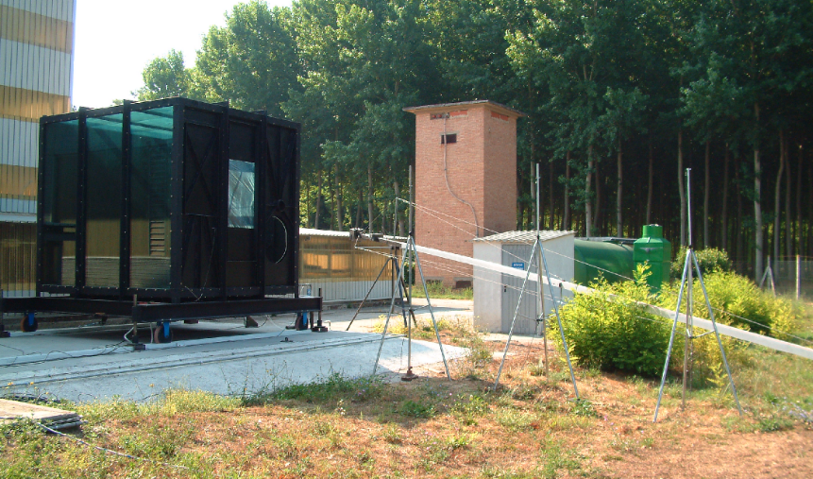
Figure 1. Example of figure and figure caption
Don’t highlight words “Figure”, and “Table” by bold font in text or in caption.
Equations should be included in the text flush to the left of the page, and numbered using Arabic numerals in rounded parentheses (1) which should be flush to the right of the page, as below:
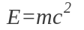, (1)
where E – energy, J; m – mass, kg; c - velocity of light, m/s.
The SI system should be used for all scientific and laboratory data.
REFERENCES should be given in the text by Arabic numerals in squared parentheses, e.g. [1], and should be ordered in the number cited. The list of references should appear at the end of the manuscript, and the title References (please use style Heading 1). Examples of references for journals and books are given below (please use style References for references). Please don’t leave line spaces between references.
- Example of journal paper. Graham, T.L., Makhviladze, G.M. and Roberts, J.P., On the Theory of Flashover Development, Fire Safety Journal, 25, No. 3, 1995, pp. 229-259.
- Example of book. Zeldovich, Y. B., Barenblatt, G.I., Librovich, V.B. and Makhviladze, G.M., Mathematical Theory of Combustion and Explosions, 1985, Plenum Press, New York.
- Example of chapter in book. Yetter, R.A., Dryer, F.L. and Golden, D.M., Major Research Topics in Combustion (Hussaini, M.Y., Kumar, A. and Voigt, F.G. Eds.), Springer-Verlag, New York, 1992, p. 309.
- Example of internal report. Margolis, S.B., Williams, F.A. and Telengator, A.M., Combustion of Porous Energetic Materials in the Merged-Flame Regime, Sandia National Laboratories Report No. SAND96-8212 UC-1409.
- Following are examples of symposium proceedings. Audouin, L. and Tourniaire, B., New Estimation of the Thermal Interface Height in Forced-Ventilation Enclosure Fires, Proceedings of the Sixth International Symposium on Fire Safety Science, 5-9 July 1999, Poitiers, in print.
- Suitor, J.W., Marner, W.J. and Ritter, R.B., The History of Heat Exchangers in Cooling Water Service, 16th National Heat Transfer Conference, St. Louis, CSME/CSChE, Paper 76, 1976.
- Magnussen, B.F. and Hjertager, B.H., On the Mathematical Modelling of Turbulent Combustion with Special Emphasis on Soot Formation and Combustion, 16th Symp. (Int.) on Combustion, Pittsburgh, PA, The Combustion Inst., 1976, pp. 711-729.

Submission of manuscript
Please submit the manuscript (only in PDF version) electronically using the Conference website: (www.ichs2017.com)

